# Week 1: Introduction

## Description of the Module

* Main Content
  + Search Methodologies
  + Machine Learning
* Books
  + Artificial Intelligence: A Modern Approach
  + Introduction to Artificial Intelligence
  + Artificial Intelligence Illuminated
* Evaluation
  + Programming assignment (50%)
    - Python (Jupyter notebook)
    - Teams of 1-3
  + Online examination (50%)
  + Programming labs
    - Python (Jupyter notebooks)
    - Expected and do help with assignment
* Practicals
  + Week 1: Python Basics
  + Search Methodologies
    - Week 2 – Heuristic search
    - Week 3 – Local search
  + Machine Learning
    - Week 4 - Supervised
    - Week 5 – Unsupervised
* Format and Structure
  + Each week:
    - 4-5 Lecture Recordings
    - 1 Practical
    - 1 Q&A Session

## 1.1 Introduction to Artificial Intelligence

* What is intelligence
  + Hard to define
  + Properties of intelligence, ability to:
    - Perceive, understand, predict
    - Learn, solve problems, devise plans
    - Play games, answer questions
  + AI attempts to understand and build intelligent entities
* What is AI
  + Can split into political spectrum type chart; 4 quadrants
    - Thinking humanly – cognitive modelling approach
    - Thinking rationally – “laws of thought” approach
    - Acting humanly – Turing est approach
    - Acting rationally – rational agent approach
* Acting humanly – Turing test
  + “Can machines think?” “Can they behave intelligently?”
  + Operational test for intelligent behaviour: The Imitation Game
  + Suggested major components of AI: knowledge, reasoning, language understanding, learning
  + Does not really work in a practical sense
* Acting rationally: rational agent
  + Rational behaviour: doing the right thing
    - The right thing: maximise goal achievement, given the available information
  + Does not necessarily. Involve thinking
  + Thinking should be in service of rational action
* AIMA book
  + Each agent implements a function that maps percept sequences to actions
  + Book covers methods of representing these functions, i.e. reactive agents, real-time planners, etc.
  + Role of learning is to extend the reach of designer into unknown environments
* Foundations of AI and related fields
  + Philosophy
  + Mathematics
  + Economy
  + Neuroscience
  + Cognitive psychology
  + Computer engineering
  + Control theory and cybernetics
  + Linguistics
* History of AI
  + 1940 – 1950: Early days
    - 1943: Boolean circuit model of brain
  + 1950 – 70: Excitement
    - AI to play chess, checkers, etc.
  + 1970 – 90: Knowledge-based approaches
    - 1980 – 88: Expert systems industry booms
  + 1990 – Statistical approaches
    - Resurgence of probability, focus on uncertainty
    - General increase in technical depth
* Summary
  + Historically different views of AI
    - Thinking vs behaviour
    - Humans vs ideal standard (rationality)
  + Consider AI related to rational action
  + An intelligent agent takes the best possible action in a situation

## 1.2 Applications of Artificial Intelligence

* Successful applications of AI
  + Natural language processing
    - Speech technologies
    - Language processing technologies
  + Computer vision
    - Face recognition
    - Image classification
  + Autonomous robotics
    - Robotics
      * Spot – nimble robot that climbs stairs and travels rough terrain
      * Atlas – most dynamic humanoid robot
    - Applications
      * Space exploration
      * Domestic help
      * Rescue
  + Self-driving cars
  + Game playing
    - Deep Blue by IBM
      * 1996: Kasparov beats Deep Blue
      * 1997: Deep Blue beats Kasparov
      * First match won against world champion
      * Processing 200 million board positions per second
    - AlphaGo by Deep Mind (Google)
      * More board positions than chess (20 vs 200)
      * 2016: beats the European champion
      * 2017: Defeats World champion
    - Used to create responsive/intelligent behaviour in NPCs
      * Create more challenging opponents
      * Examine player behaviour and change responses to make games more challenging
    - Some AI techniques
      * Pathfinding with search algorithms
      * Decision trees
      * Evolutionary algorithms
  + Decision making
    - Scheduling
      * Airline flights
      * Jobs in industry
      * Personnel
    - Cutting and packing
      * Clothing, metal industry
      * Packaging and transportation
    - Route planning
      * Google maps
      * Space exploration
    - Design of timetables
  + Summary
    - Several successful applications of AI
      * Nat language processing
      * Computer vision
      * Self-driving cars
      * Autonomous robotics
      * Game playing
      * Decision making

## 1.3 Introduction to Python

* Why Python
  + Advantages
    - Friendly and easy to learn
    - Object oriented, procedural and functional
    - Open source
    - Easy to read
    - Compact code
  + Disadvantages
    - Can be slower than compiled languages
  + One of the most widely-used programming languages
* Origin
  + Guido Van Rossum in 1991
  + Name comes from MP Flying Circus
* Characteristics
  + Object oriented, procedural and functional
  + Dynamic typing – no need to declare variables
  + Relies on indentation; no end to lines (;)
* Interpreters vs compilers

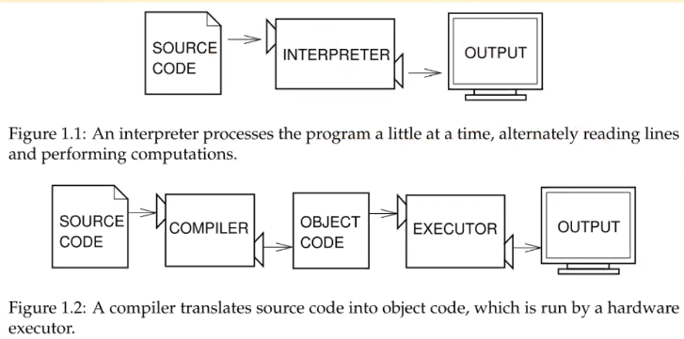

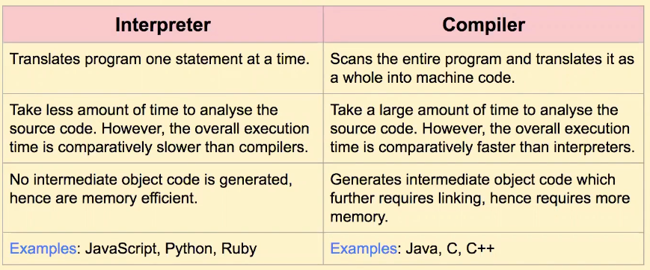

* Two ways of using python interpreter
  + Interactive mode – type code, interpreter displays results
  + Script mode – store code in file and use interpreter to execute its content
    - Python scripts end in .py
* Jupyter
  + Notebook – open-source web application to create and share documents that contain
    - Live code
    - Narrative text
    - Visualisations
    - Equations
  + JupyterLab – next-gen web-based user interface for Jupyter
* First python
  + print (“Hello World”) # Python 3
  + dynamically typed – don’t need to declare types of variables
    - more dangerous but more flexible
* Variables
  + no need to declare
  + need to assign (initialise, use of uninitialized variable raises exception
  + not fixed type
  + Numbers, Strings, Lists, Dictionaries, Tuples, Files, Other types
* Lists
  + Flexible arrays, sequence of items
    - A = [99,56,77]
  + Example operators
  + Item and slice assignment
    - A[0] = 98
    - A[1:3] = [57, 68] // replaces items 1,2
    - Del a[-1]
  + Copying a list with slices
    - a=[1,2,3]
    - b=a[:]
* Summary
  + Interpreted language, both procedural and OO modes
  + Emphasises code readability
  + Simple syntax
  + Open source, portable, mixes well with other languages
  + Widely used for AI and Machine Learning

# Week 2: Solving Problems by Searching

## 2.1 Formulating Search Problems

* Search
  + At least 4 meanings in CS
    - Search for stored data
    - For web documents
    - For paths or routes – finding set of actions that will bring from initial state to goal state; depth first search, breadth first search, branch and bound, A*, Monte Carlo tree search
    - For solutions – find solution in large space of candidate solutions; evolutionary algorithms, metaheuristics, simulated annealing, ant colony optimisation…
* Intelligent agents
  + Rational agent chooses actions maximise the expected utility
    - Agent perceives its environment through sensors and acts upon it through actuators
* Solving by searching
  + - Finding action sequences that lead to desirable states
    - What is a problem and what is a solution?
      * Problem: goal and a set of means to achieve it
      * Solution: sequence of actions to achieve that goal
    - Given precise problem definition, possible to construct a search process for finding solutions
* Pac-Man example

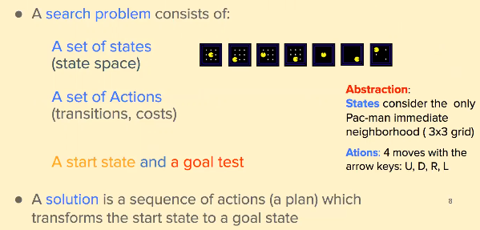

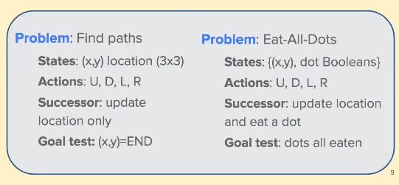

* Abstraction: selecting a state space
  + Real world absurdly complex
    - State space abstracted for problem solving
  + Need to model real world
    - Search state representing set of real states
    - Action representing complex combo of real actions
    - Solution representing real paths that are solutions in real world
* Problem formulation
  + **Initial state** where agent starts (e.g. at Arad)
  + **Actions** available to agent (e.g. Arad -> Zerind)
  + **Transition** **model** description of what each action does
  + **Goal** **test** determines whether given state is goal state (e.g. at Bucharest)
  + **Path** **cost (additive)** numeric cost to each path (performance measure sum of distances)
* Other real-world problems
  + Route or path finding
  + Airline flight planning
  + Robot navigation
* Summary
  + Search problem consists of
    - Set of states (state space)
    - Set of actions (transitions, costs)
    - Start state and goal test
  + Solution is a sequence of actions which transforms start state to goal state

## 2.2 Tree-based Search

* Tree-based search algorithms
  + Having formed problems, need to solve
  + Solution is an action sequence
  + Search algorithms work by considering various possible action sequences (plans)
  + Two types
    - Uninformed algorithms
    - Informed algorithms
* Vacuum world example
  + States – determined by both agent location and dirt locations (squares A and B)
  + Initial states – any can be designated as initial
  + Actions – 3 actions, left, right and suck
  + Goal test – checks if all squares are clean
  + Path test – each test costs 1
* State space graph
  + Mathematical representation of search problem
    - Nodes are abstracted world configurations
    - Arcs represent successors
    - Goal test is given node or set of nodes
    - In state space graph **each state occurs only once**!
    - In general state space graph too big to have in memory

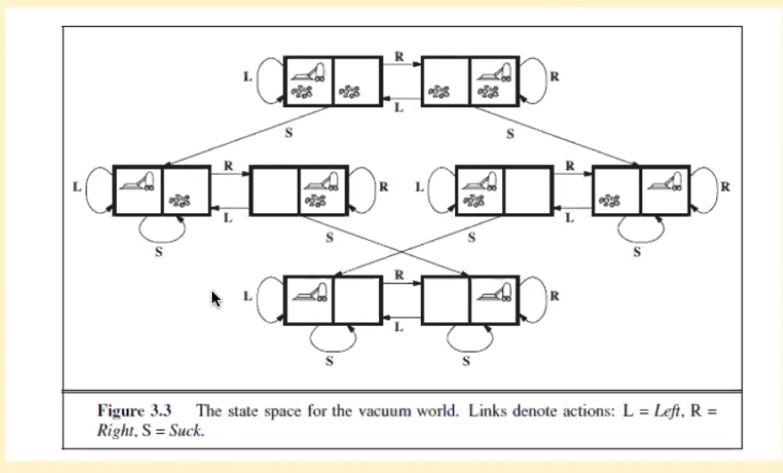

* Search trees
  + A “what if” tree of plans
  + Start state is root node
  + Children correspond to successors
  + Nodes show states but correspond to PLANS that achieve those states
  + For most problems we can never actually build whole tree
  + Same state can occur multiple times

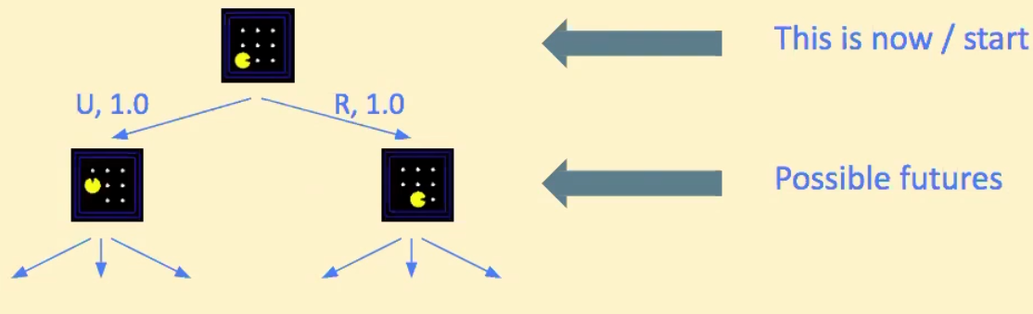

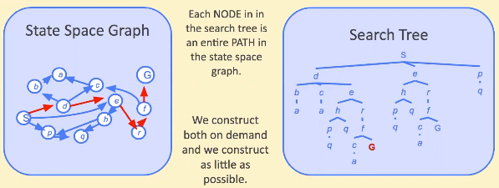

* Searching with search tree
  + Expand potential plans (tree nodes)
  + Maintain a fringe of partial plans under consideration
  + Try to expand as few tree nodes as possible

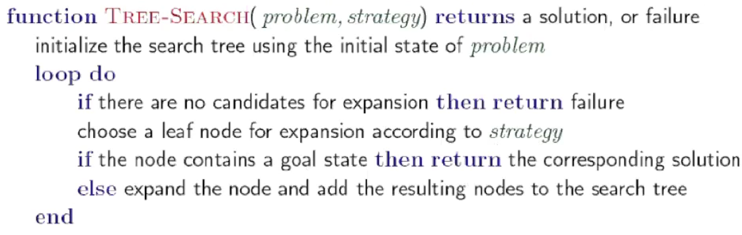

* Uninformed search strategies
  + use only info available in problem definition
  + systematically generate new states and test against goal
  + main strategies
    - breadth-first search
    - depth-first search
  + improvements
    - uniform cost search
    - depth-limited search
    - iterative deepening search
* Breadth-first search
  + Strategy – expand shallowest node first
  + Implementation – fringe is FIFO queue

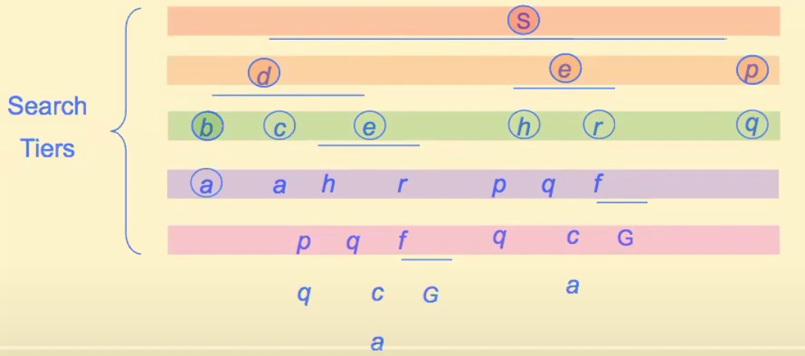

* Depth-first search
  + Strategy – expand deepest node first
  + Implementation – fringe is LIFO stack

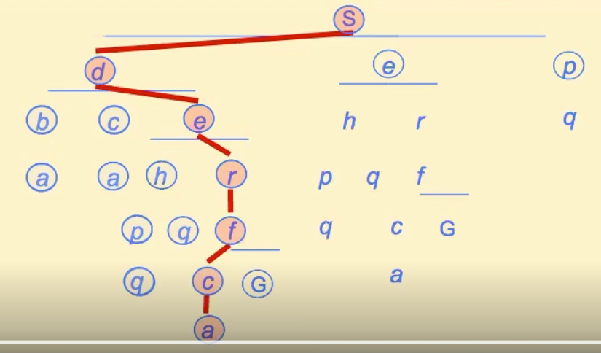

* Improvements of uninformed search
  + Uniform cost search
    - Improves BFS by always selecting lowest cost fringe node from start node for expansion
  + Depth-limited search
    - Avoid problems of DFS by imposing a maximum depth of a path
  + Iterative deepening search
    - Sidesteps issues of choosing depth limit
    - Tries all possible depth limits
    - Combines benefits of DFS and BFS
* Comparing search strategies
  + Search strategy is defined by order of node expansion
  + Strategies evaluated along following dimensions
    - Completeness – does it always find a solution if one exists
    - Time complexity – number of nodes generated
    - Space complexity – maximum number of nodes in memory
    - Optimality – does it always find least-cost solution
  + Time and space complexity are measured in terms of

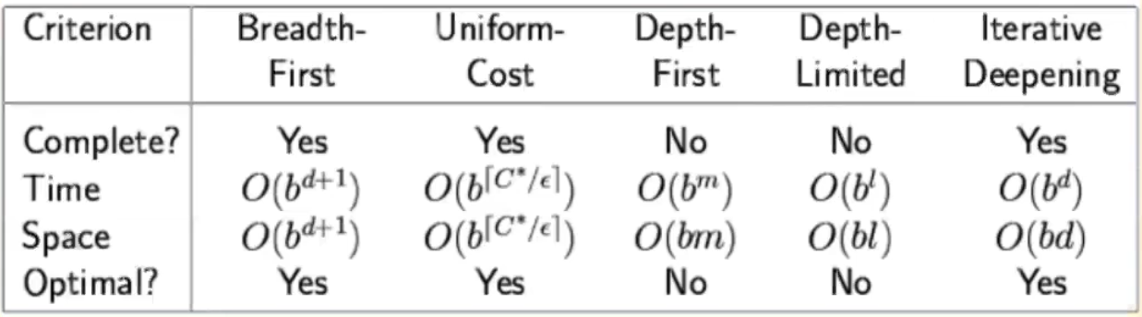

* + - b: max branching factor of search tree
    - d: depth of least-cost solution
    - m: maximum depth of state space

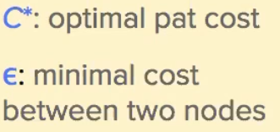

* Summary
  + Search problem
    - States (configurations of the world)
    - Actions and costs
    - Successor function (world dynamics)
    - Start state and goal test
  + Search tree
    - Nodes: represent plans for reaching states
    - Plans have costs (sum of action costs)
  + Search algorithm
    - Systematically builds search tree
    - Chooses an ordering of the fringe (unexplored nodes)
    - Optimal if it finds least-cost plans
* Informed search
  + Uninformed
    - Systematically generate new states and test them against goal
    - Explore options in every direction
    - Can find best solution but are inefficient in most cases
  + Informed
    - Use problem-specific knowledge
    - Knowledge given by heuristic function that returns a number describing desirability of expanding a node
* Search heuristics
  + A heuristic is a function that estimates how close a state is to a goal
    - Designed for particular search function
    - Examples: Manhattan distance, Euclidean distance

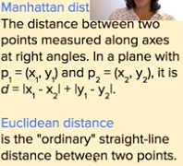

* Informed search idea
  + Strategy: expand node that you think is closest to goal state
  + Idea: use heuristic function for each node – estimate of desirability 🡪 expand most desirable unexpanded node
  + Implementation: queue sorted in decreasing order of desirability
* Informed search algorithms
  + Greedy search
    - Chooses the node that takes us closest to goal at each branch of tree (according to heuristic)
    - Example

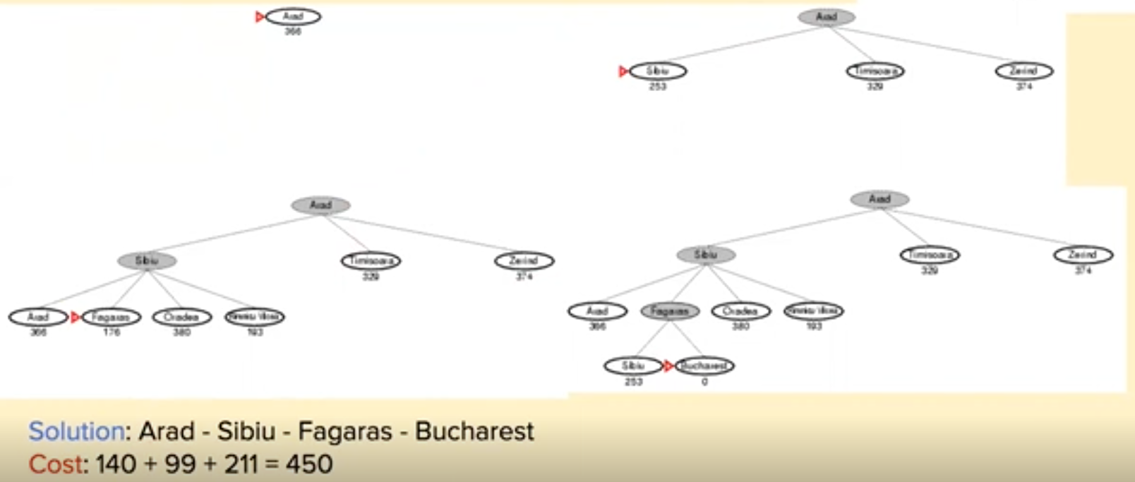

* + A* search
    - Chooses on least-cost solution path
    - Combines
      * Cost of path so far
      * Estimation of what node that takes us closer to goal
    - Node evaluation combines
      * g(n) path cost from start node to node n – already known
      * h(n) cost to get from node to goal (estimated by heuristic)
      * f(n) = g(n) + h(n)
    - f(n) is estimated cost of cheapest solution through n
    - A* uses both backward costs and (estimates of) forward cost
    - A* search is both complete and optimal
    - A* applications
      * Video games
      * Pathing/routing problems
      * Resource planning problems
      * Robot motion planning
      * Language analysis
      * Machine translation
      * Speech recognition
    - Example

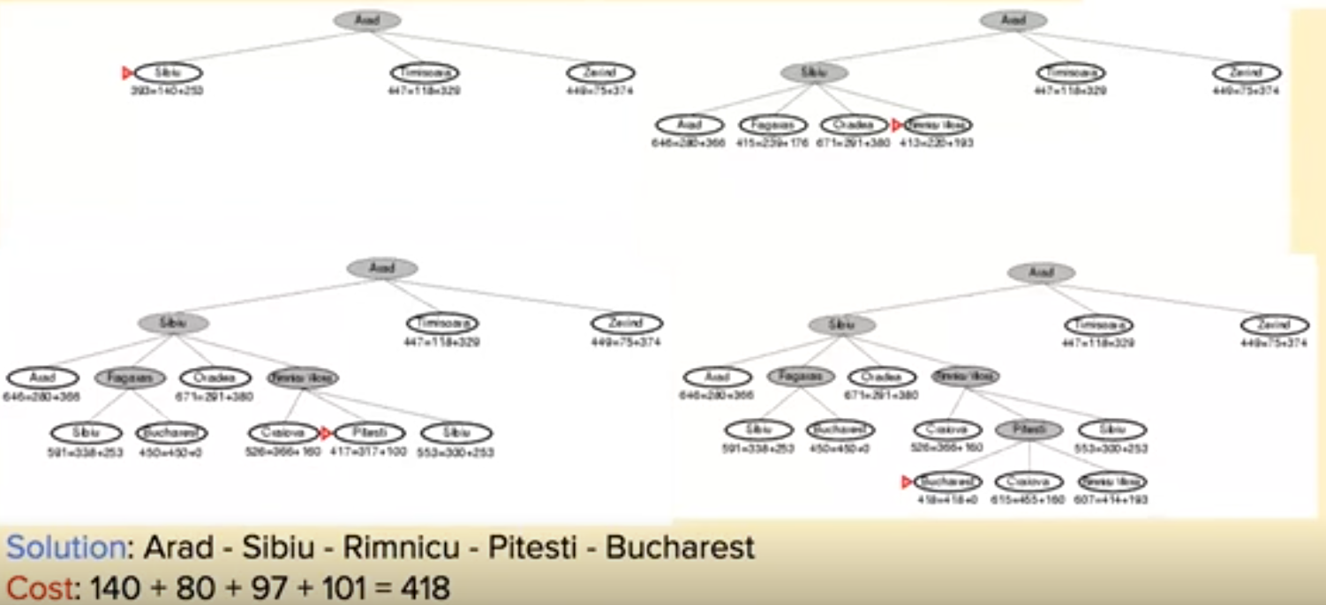

* Summary: tree-based search methods
  + Uninformed
    - Breadth-first search (BFS)
    - Depth-first search (DFS)
    - Uniform-cost search (UCS)
    - DFS improvements
      * Depth-limited search
      * Iterative deepening search
  + Informed
    - Best-first search: ‘minimum’ cost nodes are expanded first
      * Greedy search: expands node closer to goal
      * A*: expands the node on the least-cost solution path
        + Complete and optimal

## 2.3 Optimisation Problems and Heuristics

* Optimisation problems
  + Can be seen as type of search problem (search for solutions instead of search for a sequence of actions)
  + Many applications in industry, commerce, science, etc.
  + Optimisation occurs in minimisation of time, cost and risk, or maximisation of profit, quality, and efficiency
  + Examples
    - Logistics
    - Timetabling
    - Software
    - Cutting & packing
    - Computer networks and telecommunication
    - Manufacturing, production lines
  + General constrained optimisation problem:
    - Min/Max f(x)
  + Subject to:
    - Equality constraints
    - Inequality constraints
  + Search space: set of candidate solutions – all poss combinations of decision variables
  + Optimisation through search
    - Iteratively generate and evaluate candidate solutions
      * Systematic search – generate all possible solutions and pick best
      * Constructive search – start with empty solution and iteratively add components
      * (Stochastic) local search – start at some position in search space and iteratively make small changes from one position to nearby position
  + Two categories
    - Continuous
      * Continuous variables
      * Looking for set (vector) of real numbers [45.78, 8.91, 3.36]
      * Objective function has mathematical expression
      * Special cases studied in maths and OR: Convex, Linear
    - Combinatorial
      * Discrete variables
      * Looking for an object from a finite set
        + Binary digits [1,0,1,0,1,1]
        + Integer [1,53,4,67,39]
        + Permutation [3,5,1,2,4]
        + Graph
  + Example: knapsack problem
* Heuristic optimisation
  + Heuristic
    - Describes how to derive an output for any given input
    - Rule of thumb to solve problem
    - Provides no guarantees with regards to quality (optimality) of output
  + Why heuristics
    - Work well in practice
    - Trade theoretical guarantees on efficacy for practical efficiency
    - For some problems efficient exact algorithms are not known and unlikely to exist (e.g. NP hard problems)
* Greedy construction heuristic

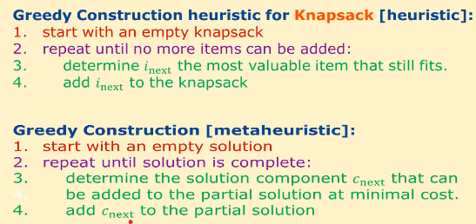

* Knapsack problem

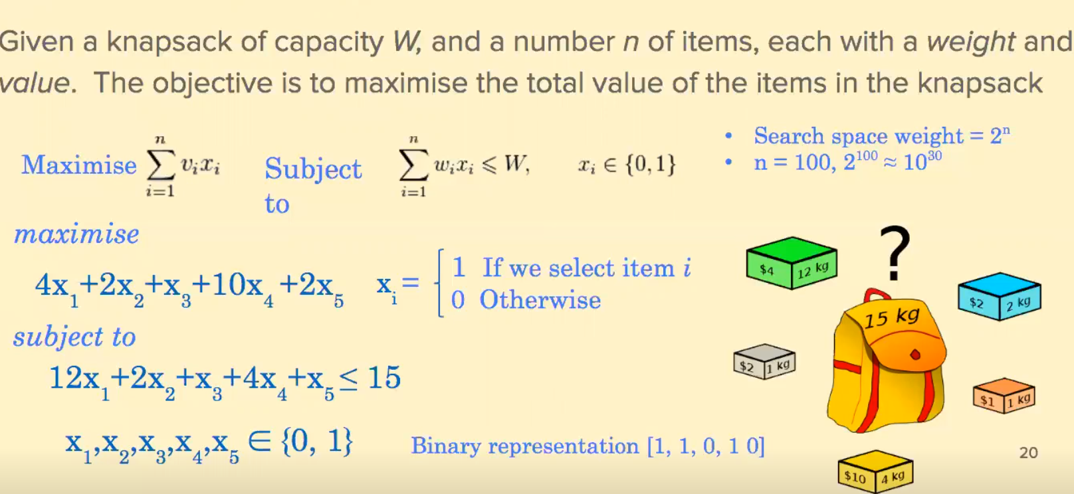

* Summary
  + Many real-world problems can be formulated as search problems
  + Can distinguish between
    - Searching for sequence of actions or paths
    - Searching for solution in large space of possible candidate solutions
  + Optimisation problems are those where a quantity needs to be maximised or minimised
  + Heuristics are rules of thumb to solve problems

# Week 3: Metaheuristics and Evolutionary Algorithms

## 3.1 Local Search and Metaheuristics

* Optimisation problems
  + Definition
    - Given
      * Search space S of feasible solutions
      * An objective function f: S -> R
    - Find s* in S such that
      * F(s*) <= f(s) for all s in S
      * S* is global optimum
  + Large scale complex optimisation problems in many areas of science and industry: transportation, logistics, finance..
* What do we mean by Random Search?
  + Attempting several solutions at random and keeping best found

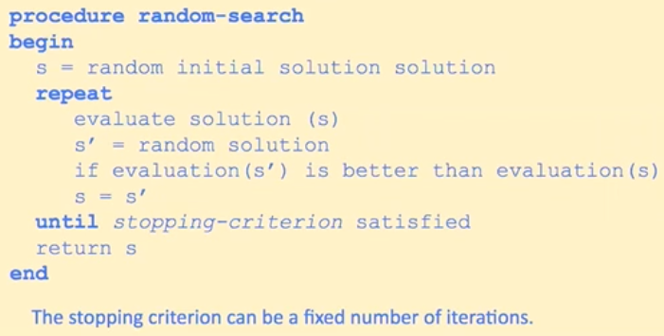

* Heuristic in Optimisation
  + An optimisation method that tries to exploit problem-specific knowledge, for which we have no guarantee to find optimal solution

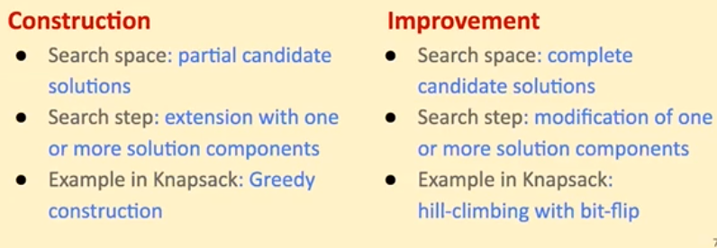

* The notion of neighbourhood
  + Region of search space that is “near” to some particular point in that space
  + Defined in terms of move operator
  + Binary representation
    - 1-bitflip mutation: flipping a single bit in the given bit string
    - For strings of length n, every solution has n neighbours

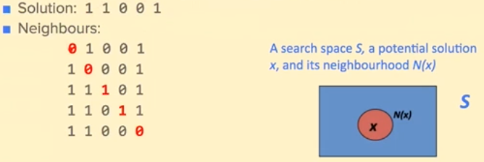

* + - 1-flip: solutions generated by flipping a single bit in the given bit string
      * Example: 11001 🡪 01001
    - 2-flip: solutions generated by flipping two bits in the given bit string
      * Example: 11001 🡪 01011
    - k-flip: can be generalised for larger k, k<n
* Hill-climbing (first improvement, randomly)

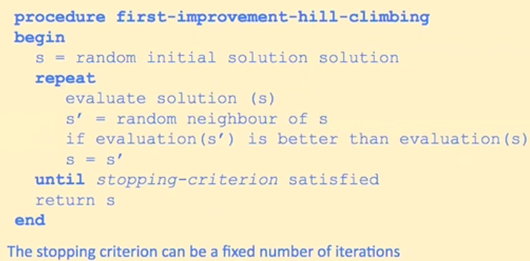

* Implementation: Binary Representation
  + 1-flip mutation

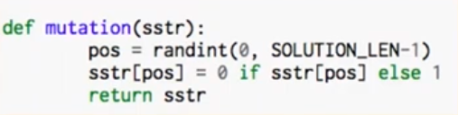

* Hill-climbing (best improvement)

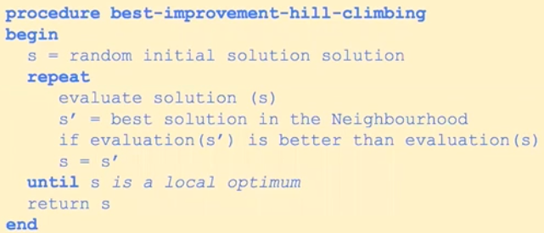

* Hill-climbing methods
  + Weaknesses
    - Usually terminate at solutions that are local optima
    - No info as to how much the discovered local optimum deviates from the global (or even other local optima)
    - Obtained optimum depends on starting point
  + Advantages
    - Very easy to apply – only needs
      * A representation
      * The evaluation function
      * A neighbourhood
    - Used in combo with other heurstics (memetic algorithms, iterated local search)
  + Problem: depending on initial state, can get stuck in local maxima

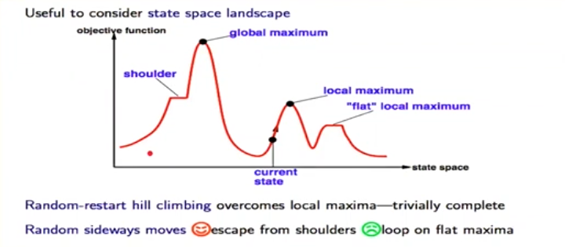

* What is a metaheuristic?
  + Extended variants of improvement heuristics
  + General-purpose solvers, usually applicable to a large variety of problems
  + Use two phases during search
    - Intensification (exploitation): focus applications of operators on high-quality solutions
    - Diversification (exploration): systematically modifies existing solutions such as new areas of search space are explored
* Multiple restarts hill-climbing
  + Simple strategy to improve hill-climbing
  + Have additional loop, repeat hill-climbing for a number of times from different starting solution

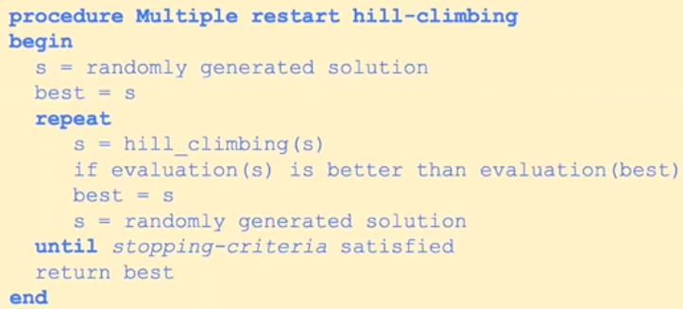

* Iterated local search
  + Simple strategy to improve hill-climbing
  + Have an additional loop, repeat hill-climbing for a number of times from a perturbed solution

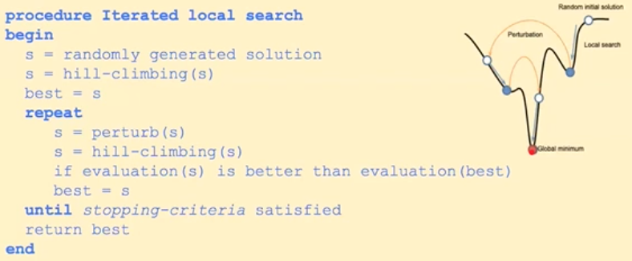

* Simulated Annealing
  + Key idea: provides mechanism to escape local optima by allowing moves that worsen objective function value
  + Annealing
    - Candidate solutions
    - Objective function
    - Globally optimal solutions
    - Parameter T
  + Annealing algorithm
    - Start with random solution s
    - Choose some nearby solution s’
    - If new solution better (i.e. f(s’) <= f(s)) take it as the current solution
    - If worse, accept with probability that depends on deterioration f(s)-f(s’) and a global parameter T

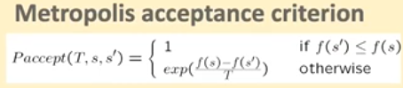

* Summary
  + Aim is to design search algs that can
    - Escape local optima
    - Balance exploitation and exploration
    - Make search independent from initial config
  + Example single point search algs
    - Multiple restart hill-climbing
    - Iterated local search
    - Simulated annealing
    - Many others

## 3.2 Optimisation Problems and Applications

* Travelling salesman
  + Size of search space = (n-1)!/2
    - Gets large VERY quickly
* Vehicle routing problem
  + Given: a set of customers a set of vehicles and a central depot
  + Goal: design minimum cost routes visiting all customers
  + Representation: a set of routes, one for each truck
  + Objective: reduce the no trucks used and total distance travelled
* Optimisation problems
  + Logistics
  + Manufacturing
  + Timetabling
  + Cutting and packing
  + Computer networks
  + Software
* Application: Neuroevolution
  + EAs used to generate NN weights, topologies, rules or ensembles
  + Fitness function measures performance in the task
  + Can be applied more widely than supervised learning algorithms
  + Main motivation: to train NNs in sequential decision tasks with sparse reinforcement information
* Summary
  + Optimisation problems
    - Travelling salesman
    - Vehicle routing
    - Logistics, transportation, manufacturing, etc.
    - Engineering design
    - Other fun and research examples

## 3.3 Evolutionary Algorithms

* Classification of optimisation algorithms
  + Single solution algorithms are exploitation oriented
  + Population-based algs are exploration oriented

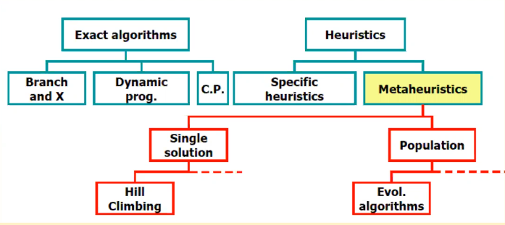

* Classification of metheuristics

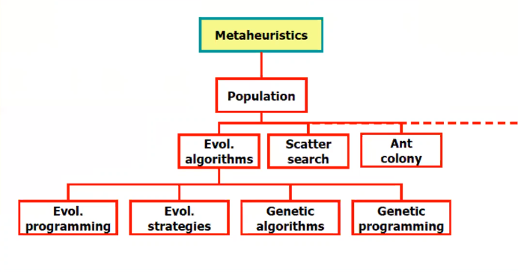

* What is an evolutionary algorithm?
  + EAs fall into the cat metaheuristic algs
  + They are stochastic, pop-based algs
  + Inspired by process of natural selection
  + Variation operators (recombination and mutation) create the necessary diversity and thereby facilitate novelty
  + Selection reduces diversity and acts as a force pushing quality
* Evolution by natural selection
  + Variation
  + Hereditary transmission
  + High rate of pop growth
  + Differential survival and reproduction
* Evolutionary computation
  + Branch of computational intelligence that study methods that mimic evolution by natural selection with the aim of solving complex design and optimisation problems

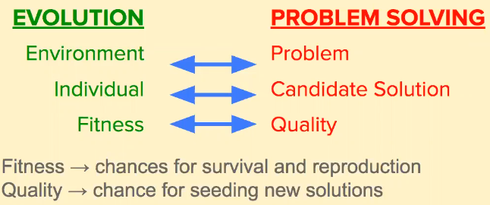

* Outline of evo algorithm

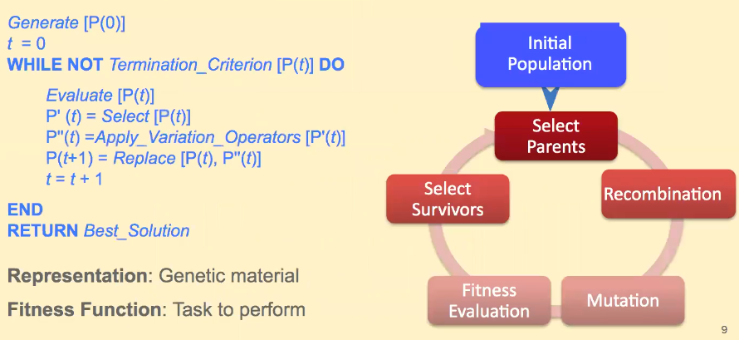

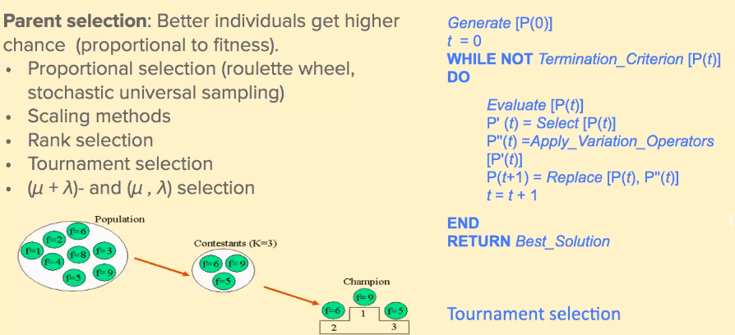

* + Replacement
    - Generational: each generation set of parents replaced by offspring
    - Steady-state: one offspring generated per generation – one member is replaced
    - Generation gap: proportion of the population is replaced
    - All of these work as well as the others

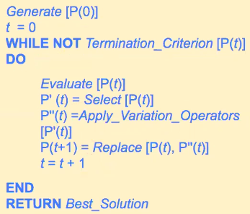

* Search operators for binary representation
  + Mutation
    - Alter each gene independently with a probability Pm (mutation rate)
    - Typically 1/chromosome_length

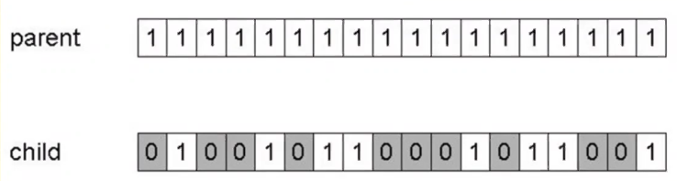

* + Recombination/crossover
    - One-point
    - N-point
    - Uniform
    - Pc typically in range (0.6, 0.9)

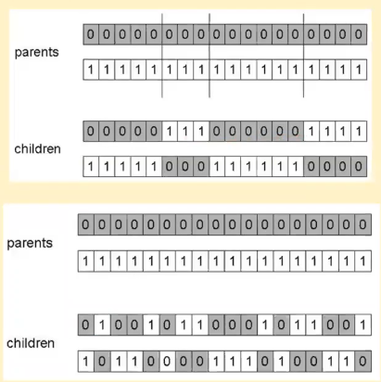

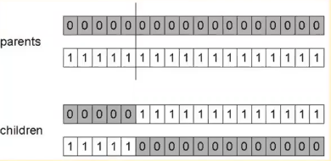

* Search operators for permutation representation
  + 2-swap mutation
    - Solutions generated by swapping two cities from given tour
    - Every sol has n(n-1)/2 neighbours



* + Inversion mutation
    - Pick subset of genes at random
    - Invert values in those positions



* + Scramble mutation
    - Pick subset of genes at random
    - Randomly rearrange values in those positions



* + Example recombination: order crossover
    - Choose random crossover point
    - Copy first parts into children
    - Create second part by inserting values from other parent
      * In the order they appear there
      * Beginning after crossover point
      * Skipping values already in child
      * Wrapping around at the end

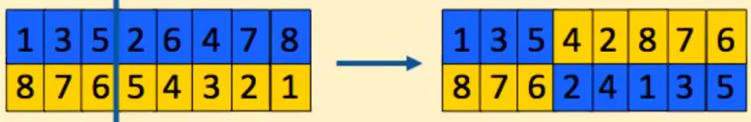

* Other evo algorithms
  + Evolution strategies
    - Specialised in continuous search spaces
    - Rechenberg & Schwefel in the 60s
    - Special feature: self-adaptation of mutation parameters
  + Genetic programming
    - Evolve a pop of computer programming
    - Applied to machine learning tasks (prediction, classification…)
    - Representation
      * Non-linear genomes: trees, graphs…
      * Linear genomes: grammatical evolution
* Other pop-based algorithms
  + Ant colony optimisation
    - ants build solutions incrementally by moving on the graph
  + Particle swarm optimisation
* Summary
  + Population-based algorithms
    - Inspired by natural selection
    - Main variants (GA, Hybrid, ES, GP)
    - Other population-based approaches
    - Swarm intelligence

# Week 4: Machine Learning (Supervised)

## Introduction to Machine Learning

* What is machine learning?
  + Science of getting computers to act without being explicitly programmed
  + A system is learning if it improves its performance on future tasks after making observations about the world
  + Field of ML concerned with question of how to construct computer programs that automatically improve with experience
* Example
  + Task T: playing checkers
  + Performance measure P: percent of games won in world tournament
  + Training experience E: games played against itself
  + Designing a learning system, select
    - Type of knowledge to be learned
    - Representation for this knowledge
    - A learning mechanism
* Why do we need learning algorithms
  + Designers cannot anticipate all possible situations
  + Designers cannot all changes over time
  + Sometimes human programmers have no idea how to program a solution themselves (e.g. face recognition)
* Types of machine learning algorithms
  + According to feedback available to learn from:
  + Supervised
    - Given example input-output pairs, learn a function that maps from input to outputs
    - Tasks: classification, regression
  + Unsupervised
    - Given inputs, learn patterns even though no explicit feedback is supplied
    - Tasks: clustering, dimensionality reduction
  + Reinforcement
    - Given feedback from the environment *rewards, punishments), determine the ideal behaviour
    - Tasks: game playing, online control
* Typical machine learning tasks (supervised)
  + Binary class
    - Predict simple yes/no response, only two classes
    - Applications: diagnostics, spam detection
  + Multiclass class
    - Identify an object into one of a number of classes
    - Applications: is a story about politics, science, entertainment, etc.
  + Regression
    - Predicting continuous-valued attribute associated with an object
    - Applications: drug response, stock prices, etc.
  + Ranking
    - Put set of objects in order of relevance
    - Applications: ranking preferences for movies/books, Google search
* Typical machine learning tasks (unsupervised)
  + Clustering
    - Organise similar items into groups
    - Applications: customer segmentation, grouping experiment outcomes
  + Dimensionality reduction
    - Taking high dimensional data and embedding it in a lower dimension space
    - Low-dimension data representations that remove noise but retain the signal of interest can be instrumental in understanding hidden structures and patterns
    - Applications: feature extraction, data compression, exploration and visualisation
* Terminology

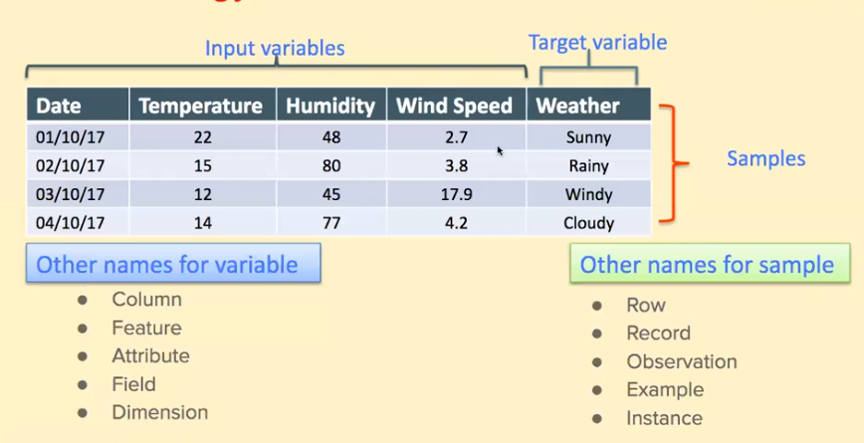

* Variable types
  + Numeric
    - Numbers of every kind
  + Categorical (also called qualitative)
    - Labels, names, categories
  + String
  + Date
* What is a machine learning model?

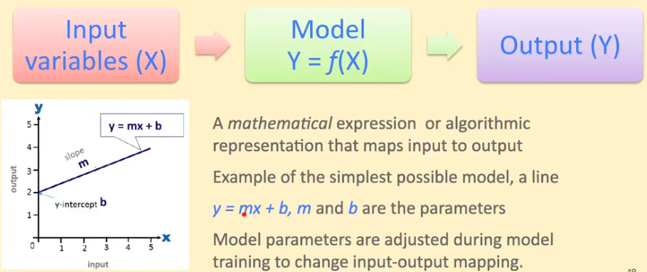

* What is overfitting?
  + When statistical model or machine learning algorithm captures the noise of the data (as opposed to the signal)
  + Intuitively occurs when model or algorithm fits the data too well
  + Is often a result of an excessively complicated model
  + Can be prevented by fitting multiple models and using validation or cross-validation to compare their predictive accuracies on test data.
* Training set and testing set
  + ML is about learning some properties of a data set and then testing those properties against another data set
  + ML algorithms are evaluated by splitting data set into two sets:
    - Training set: learning the model
    - Testing set: test the quality (accuracy) of the model

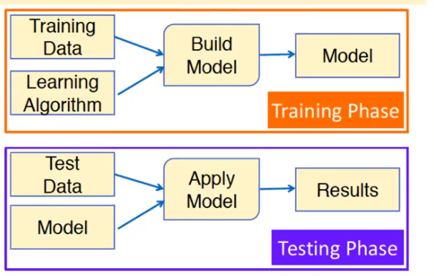

* Summary
  + Machine learning is the science of getting computers to act without being explicitly programmed
  + ML builds a model that can be used for predicting the future or making decisions
  + ML types: Supervised, Unsupervised, Reinforcement
  + ML tasks: Classification, Regression, Clustering
  + No single algorithm is the best suited to all tasks and problems

## Decision Trees

* Decision trees
  + Supervised learning is a two-step process: learning and prediction
  + Learning: model is developed based on given training data
  + Prediction: model is used to predict the response for new data
  + Decision trees
    - Popular classification algorithms easy to understand and interpret
    - Applied to both classification and regression problems
    - Decisions are reached by performing a number of tests (questions) on the attributes
  + Example

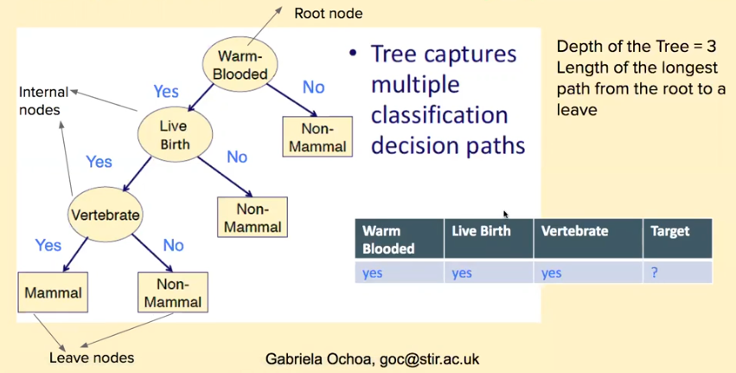

* Decision tree induction (learning)
  + Using a set of training data to generate a decision tree that correctly classifies the training data
  + If the learning has worked, this decision tree will then correctly classify new input data as well
  + Example decision tree induction algorithms
    - ID3
    - MARS
    - CHAID
    - CART
    - C4.5
  + Aim: find a small tree consistent with the training examples
  + Greedy divide-and-conquer strategy: always test the most important attribute first – this test divides the problem up into smaller subproblems that then can be solved recursively
  + Most important attribute: the one that makes the most difference to the classification of an example – the one with most information gain
  + Idea is to get the classification with a small number of tests
  + Paths in the tree will be short and tree as a whole will be shallow
* ID3 algorithm
  + Start with the whole training set S as the root node
  + Iterate through the very unused attribute of the set S and calculate Entropy and Information Gain of this attribute
  + Select the attribute which has the largest Information Gain
  + Split the set S by the selected attribute to produce a subset of the data
  + Continue to recur on each subset, considering only attributes never selected before
* What is entropy
  + Measure of randomness in info being processed

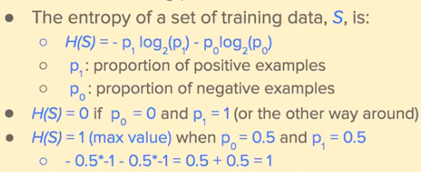

* Information gain of an attribute
  + Reduction in entropy it brings to the data
  + To compute IG, need to calculate the entropy of each subset of the training data as broken by the attribute
  + Example: movie success

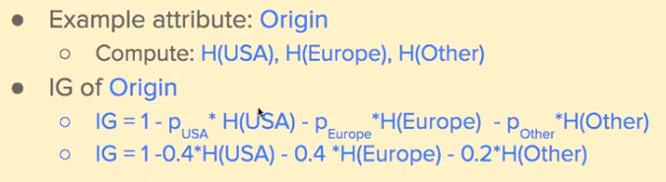

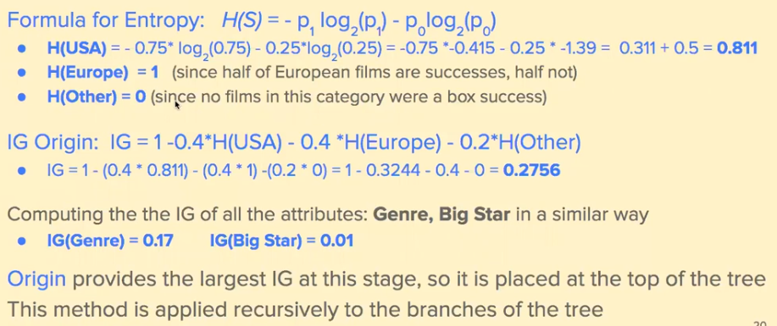

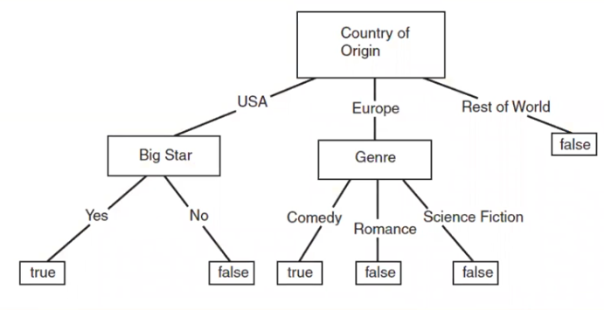

* Summary
  + ML builds a model that can be used for predicting the future or making decisions
  + Covered Classification tasks using a Supervised method: Decision Trees
  + Covered how Decision Trees are created/learned from training data

## The K-Nearest Neighbours Algorithm

* Nearest Neighbour algorithm
  + Example of instance-based learning
  + Do not generalise from training data to produce a model to match all input data
  + Instead, store the training data and use it to determine a classification for each new piece of data as it is encountered
  + Operates in situations where
    - Each instance can be defined by an n-dimensional vector (n attributes)
    - Classifications are discrete values
* KNN algorithm
  + Based on feature similarity
  + Given new point whose class we want to predict, we find a number of close neighbours to the new point in the training set
  + Predict the label (class) of the new point according to the class of the neighbours
  + How many neighbours? K is a parameter of the algorithms
  + In order to feed neighbours, we need notion of distance
  + Commonly used distance: Euclidean Distance
* Euclidean
  + Measure of the straight line between two points

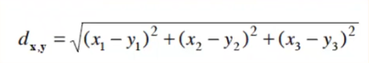

* KNN
  + K integer number small and odd
  + Object classified by a majority vote of its neighbours
  + Assigned to class most common among its K nearest neighbours
  + What is the class of the testsample?

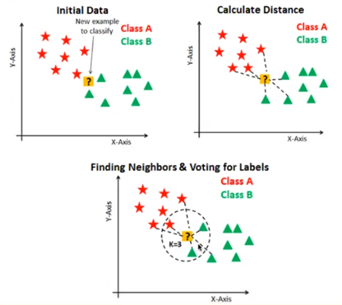

* Summary of KNN Algorithm
  + Positive integer K is specified, along with new sample
  + We select the K entries in our dataset which are closest to the new sample, according to a given distance metric
  + Find the most common classification of these entries
  + This is the classification we give to the new sample
* Characteristics of KNN Algorithm
  + Instance-based or non-generalising
  + Doesn’t attempt to construct a general internal model, but simply stores instances of the training data
  + Pros
    - Simple and versatile: used for classification and regression
    - Non-parametric: useful for non-linear data
  + Cons
    - High memory usage – algorithm stores all training data
    - Prediction time can be slow if dataset is large
* Python library: scikit-learn
  + Open source for machine learning in Python
  + Improved continuously, active community
  + Easy to use API
  + Good documentation

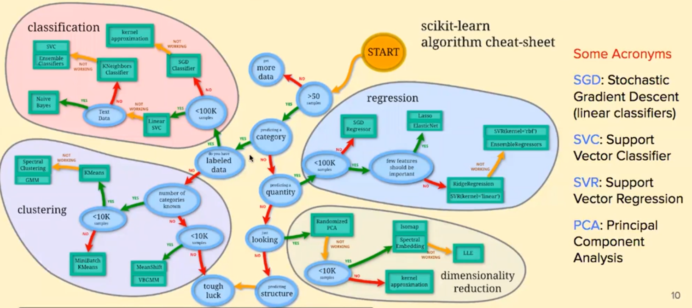

* Labs using Python library scikit-learn
  + ML Lab 1: Classification with KNN and Decision Trees
  + ML Lab 2: Clustering with K-means and Hierarchical Clustering
  + Famous example dataset: IRIS flowers
    - 4 features from each sample: length and width of sepals and petals, in centimetres
* Summary
  + ML is the science of getting computers to act without being explicitly programmed
  + Supervised ML Tasks: Classification, Regression
  + Covered Classification tasks using Supervised methods: Decision Trees and KNN
  + scikit-learn: powerful ML library for Python

# Week 5: Machine Learning (Unsupervised)

## Unsupervised Machine Learning

* Introduction
  + Unsupervised Learning – useful info can be gained from examples whose classes are not known
  + Interested in discovering useful properties of available data rather than learning classifiers
* Main types of machine
  + Supervised
    - Inferring function from labelled training data
    - Training data consist of a set of training examples
    - Each example in a pair has an input vector and a desired output value
    - Algorithms: Decision trees, neural networks, Bayesian methods…
  + Unsupervised
    - Trying to find hidden structure in unlabelled data
    - Requires data but no labels
    - Examples are unlabelled, there is no error or reward signal to evaluate a potential solution
    - Algorithms: clustering, PCA, self-organised maps…
* Clustering
  + Goal is to automatically organise data into relatively distinct groups or clusters such that
    - Instances in the same cluster must be similar as much as possible
    - Instances in different clusters must be different as much as possible
    - Measurement for similarity and dissimilarity must be clear and have the practical meaning – we will need distance metrics
* Applications of clustering
  + Market segmentation
  + Document grouping
    - Web doc clustering for search users
    - Use descriptors: sets of words that describe the contents within the cluster
    - Involves tokenization (parsing text data into smaller units) stemming (fundamental parts of words), removing stop words and punct
  + Biology and medicine
  + Social sciences and business
  + Computer science and AI
* Two types of clustering methods
  + Partitional clustering
    - Seek to partition the observations into a pre-specified number of clusters
    - Produces a set of non-overlapping groups
    - Generally faster algorithms
  + Hierarchical clustering
    - Do not know in advance how many clusters we want
    - Produces a tree-like visual representation (dendrogram) that allows us to view the clusterings obtained for each poss number of clusters, from 1 to n
    - Generally takes longer
* High dimensional data
  + Visualising high-dimensional data is hard
    - Can plot 2 or 3 dimensions and a few more through use of things like line width, colour, point shape etc
    - Cannot visualise high-dimensional data directly
  + Some ways around this limitation
    - Dimensionality reduction – projecting data: PCA, t-SNE
    - Special visualisation tools: parallel coordinates, radard/spider charts, scatterplot matrices
* Dimensionality reduction
  + Process of reducing the dimension of dataset
  + In order to
    - Have better prediction models
    - Visualise that data to understand it better
  + Many methods
    - Feature selection and feature engineering
    - Linear methods: PCA (principal component analysis), factor analysis, LDA (linear discriminant analysis)
    - Non-linear methods: MDS (multidimensional scaling), Isomap, t-SNE
* Summary
  + Unsupervised learning
    - Have a set of features, do not have response variable
    - Not interested in prediction but instead in finding some patterns in the data
  + Main two tasks
    - Clustering
    - Dimensionality reduction
  + Many real-world interesting applications

## Partitional Clustering (K-Means)

* Clustering
  + Input is a set of examples each described by a vector of attribute values but no class labels
  + Output is a set of two or more clusters of examples
  + The system should automatically identify groups of similar examples
* Two clustering methods
  + In K-means clustering we seek to partition the observations into a pre-specified number of clusters
  + In hierarchical clustering
    - Do not know in advance how many clusters we want
    - End up with a tree-like visual representation of the observations, called a dendrogram
    - The dendrogram allows us to view at once the clusterings obtained for ach poss number of clusters, from 1 to n
* Cluster characteristics
  + How to describe clusters
    - Simplest approach relies on centroid
    - If all attrs are numeric, the centroid is identified with the averages of the individual attrs
    - Example: (2,5) (1,4) (3,6) centroid is (2,5) because (2+1+3/3) and (5+4+6/3) = (2,5)
  + What should clusters be like
    - Should not overlap each other
    - Each example must belong to one and only one cluster
    - Within same cluster, examples should be relatively close to each other – closer to other members than members of other clusters
* Measuring distance
  + Clustering algorithms need a mechanism to evaluate the distance between an example and a cluster
  + When clusters described by centroid, Euclidean distance between example and centroid is a good way of measuring distance
  + Euclidean distance can be applied directly when attributes are numerical
  + When attributes categorical, Euclidean distance can also be used
    - Boolean variables can be transformed into 0 and 1
    - Other categorical variables (e.g. Seasons) can be transformed into Boolean i.e. summer yes/no

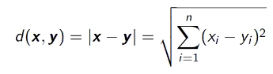

* K-means
  + Randomly select k points in dataset, these serve as initial centroid for the observations
  + Assign each observation to the cluster whose centroid is closest
  + Iterate until cluster assignments stop changing:
    - For each of the k clusters, compute the cluster centroid
    - Assign each observation to the cluster whose centroid is closest
  + Notes
    - Centroid: point in the centre of the cluster
    - Notion of closest is defined using Euclidean distance
    - Ties should be broken deterministically to avoid looping, i.e. assign to cluster with lowest index
    - Centroid does not have to be (and rarely is) one of the original data points
* Properties of the algorithm
  + K-means is guaranteed to decrease the distance from examples to their cluster centroids
  + However it is not guaranteed to find best solution
  + K-means not deterministic
    - Requires initial centroids (randomly picked)
    - Does matter what initial centroids are
  + Could go wrong – algorithm may get stuck in local optimum
* Local optimum

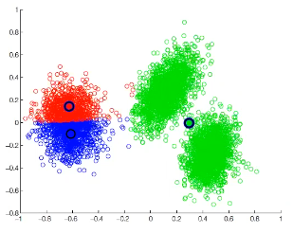

* + Various schemes for preventing this kind of thing
    - Multiple restarts
    - Variance-based split/merge
    - Initialisation heuristics
* Summary
  + In K-mean clustering, seek to partition the observations into a pre-specified number of clusters
  + Performance of algorithm depends on the initialisation (initial centroids)
  + Still very much used in practice
  + Main limitation is the need to suggest the number of clusters K in advance

## Hierarchical Clustering

* Hierarchical slustering
  + K-means clustering requires us to pre-specify the number of clusters K – can be a disadvantage
  + HC does not require that we commit to a particular choice of K
  + HC algs produce a hierarchy which can be visualised as a dendrogram (tree)
  + Histogram helps us to decide on the number of clusters K
  + Two types of HC
    - Agglomerative (bottom-up)
      * Each example starts as single-element cluster (leaf)
      * At each step, two clusters that are most similar are combined into a new bigger cluster (nodes)
      * Iterate until all points are member a single big cluster (root)
    - Divisive (top-down)
      * Start with single cluster (root) with all examples
      * At each step, the most heterogenous cluster is divided into two
      * Iterate until all examples are in their own cluster
* Measuring siumilarity
  + Need a way of measuring the similarity between two clusters
  + As discussed for K-means, we can measure the (dis)similarity of observations using a distance measure such as the Euclidean distance
  + How do we measure dissimilarity between two clusters of obeservations
  + Number of different cluster agglomeration methods (i.e. linkage methods) have been proposed
    - Minimum or single linkage
    - Maximum or complete linkage
    - Mean or average linkage
    - Inter cluster variance
* Linkage methods
  + Linkage method determines the metric used for merging clusters – two clusters merged if they are close
  + All pairwise distances between observations in cluster A and observations in cluster B are computed
  + Types
    - Single
      * Minimal inter-cluster distance
      * Shortest distance between observations of pairs of clusters
    - Complete
      * Maximal inter-cluster distance
      * Maximum distance between observations of pairs of clusters
    - Average
      * Mean inter-cluster distance
      * Average distance between observations of pairs of clusters
    - Ward
      * Inter-cluster variance
      * Variance of the pairs of clusters
      * Sum of squared differences within all clusters
* Agglomerative clustering
  + Input set of examples without labels
    - Let each example form one cluster – for N examples, create N clusters, each containing single example
    - Find pair of clusters with the smallest cluster-to-cluster distance
    - Merge the two clusters into one, reducing total number of clusters to N-1
    - Iterate until all examples are member a single big cluster
* Conclusions
  + HC seeks to build a hierarchy of clusters
  + Can decide on the number of clusters **after** exploring the dendrogram
  + Unsupervised learning is important for understanding the variation and grouping structure of a set of unlabelled data, and can be a useful pre-processor for supervised learning
  + Intrinsically more difficult than supervised learning because there is no gold standard, like an outcome variable and no single objective, like test set accuracy

# Week 6: Advanced Topics and Conclusion